Year 10
Pathway 10A

Mini-Test 4
Probability


Name: ______________________ Class: ______ Time: 35 minutes Total Mark:____/31

Show working and answers on this sheet. Show working in sufficient detail to support your answers. Incorrect answers without supporting reasoning will be allocated zero marks.

Resources: 1 A4 page of notes (1 side), Calculator allowed.

Question 1 9 marks (1 ,2, 2, 2,2)
Consider rolling a red and a black die and the probabilities of the following events:
Event A the red die lands on 5
Event B the black die lands on 2
Event C the sum of the dice is 10.
a) The initial probability of each event described is: (Circle the correct answer)
A P(A) = $\frac{1}{6}$ B P(A) = $\frac{5}{6}$ C P(A) = $\frac{5}{6}$
P(B) = $\frac{1}{6}$ P(B) = $\frac{2}{6}$ P(B) = $\frac{2}{6}$
P(C) = $\frac{1}{6}$ P(C) = $\frac{7}{36}$ P(C) =$\frac{5}{18}$

D P(A) = $\frac{1}{6}$ E P(A) = $\frac{1}{6}$
MC P(B) = $\frac{1}{6}$ P(B) = $\frac{2}{6}$
P(C) = $\frac{1}{12}$ P(C) = $\frac{1}{12}$

b) Calculate the following probabilities:
i P(A|B) ii P(B|A)

iii P(C|A) iv P(C|B)

Question 2 8 marks (4, 1, 1, 2)

Sam has 12 cards numbered 1 to 12. She draws 2 cards, one after another, without placing them back.
Let P= {number divisible by 3} and N= {number not divisible by 3}

- Draw a tree diagram to show this information

- Find P (both cards show a number divisible by 3)

- Find P (no cards show a number divisible by 3)

- Find P(at least one card shows a number divisible by 3)

Question 3 7 marks (3, 1, 1, 2)

From the 20 people in an aquatic team, 15 like swimming (S), eight like diving (D) and three like both swimming and diving.
- Represent the information in a two-way table.

- A person from the aquatic team is chosen at random. Find the probability that
the person:
i likes both swimming and diving.

ii likes only diving.

iii likes swimming given that they like diving.

Question 4 7 marks (1, 1, 1, 1, 1, 2)

Consider the following Venn Diagram:

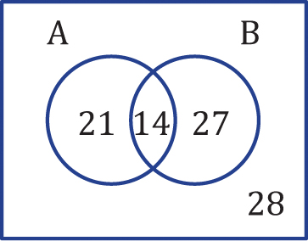

a Find:

i n(A′)

ii n(A′ ∪ B′)

b Find:

i Pr(A)

ii Pr(A ∪ B′)

iii Pr(B | A)

c Are the events A and B independent? Why/why not?

END OF TEST

